9 SCIENCE PHYSICS UV RADIATION INVESTIGATION 2016

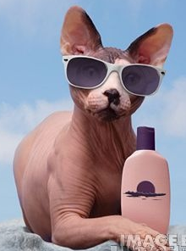

Name:_________________________ Teacher: ______________________

Form:_________________________ Due date:_____________________

Plagiarism
You must write in your own words, not copy sentences word for word from another student or another source.
Plagiarising = instant zero on assignment and you will have to re-do it.

Assessment policy
Give me a sick note/legitimate reason from parent BEFORE due date = new negotiated due date.
One day late = -20% taken off mark
Two days late = -40% taken off mark
Three days late = mark of zero given, students are required to attend a detention and are still required to submit the assignment.

Aim: to test the strength of different sunscreens against UV radiation.

If you are not at school the day this assignment is due, please email it to your teacher by the given deadline.

_________________________@aranmore.wa.edu.au

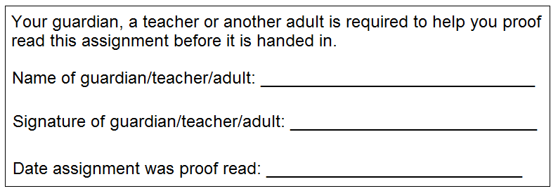

Task: design an experiment that allows you to investigate which SPF of sunscreen protects the best against UV radiation.

Available equipment that you can use:

Sunscreen SPF 50+ Wooden pop sticks
Sunscreen SPF 30+ Cardboard
Sunscreen SPF 15+ Stopwatches
Plastic spoons Plastic trays
UV safe wristband in bag (it MUST stay sealed in the bag)

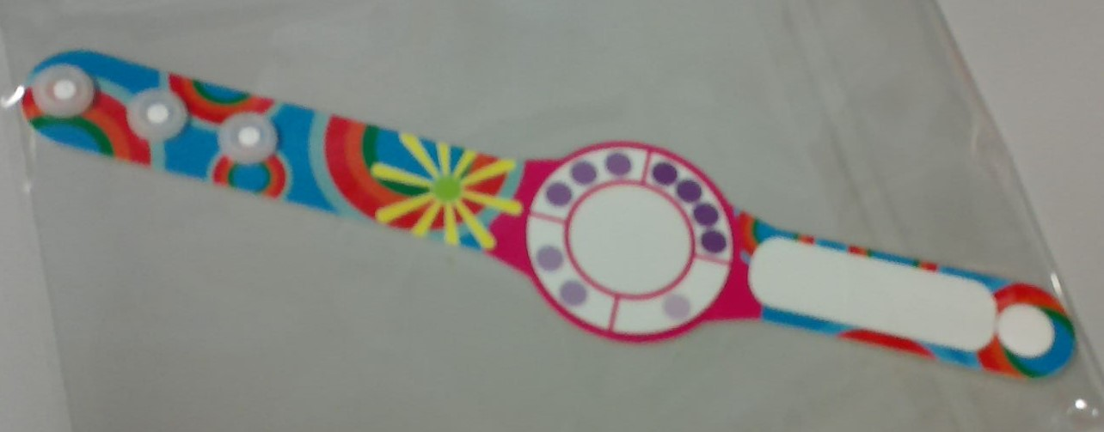

Introduction

There are different subtypes of ultraviolet (UV) radiation; UVA, UVB and UVC radiation.

Identify which ultraviolet radiation subtypes a broad-spectrum sunscreen protects you from. (1 mark)

_________________________________________________________________________________________________

Outline what UVA rays can do to the skin. (1 mark)

_________________________________________________________________________________________________

_________________________________________________________________________________________________

Outline what UVB rays can do to the skin. (1 mark)

_________________________________________________________________________________________________

_________________________________________________________________________________________________

In your own words, explain how sunscreen works. (Minimum of two sentences). (2 marks)

_________________________________________________________________________________________________

_________________________________________________________________________________________________

_________________________________________________________________________________________________

_________________________________________________________________________________________________

_________________________________________________________________________________________________

_________________________________________________________________________________________________

In your own words, state what SPF stands for (it is an abbreviation) and outline what SPF measures. (2 marks)

_________________________________________________________________________________________________

_________________________________________________________________________________________________

_________________________________________________________________________________________________

_________________________________________________________________________________________________

_________________________________________________________________________________________________

_________________________________________________________________________________________________

_________________________________________________________________________________________________

_________________________________________________________________________________________________

Hypothesis: (one sentence prediction including dependent and independent variables which does not use personal language like ‘I’, ‘we’) (2 marks)

_________________________________________________________________________________________________

_________________________________________________________________________________________________

_________________________________________________________________________________________________

_________________________________________________________________________________________________

_________________________________________________________________________________________________

Materials: (list all materials used, be specific with number of items used and amounts/sizes) (2 marks)

_________________________________________ ______________________________________________

_________________________________________ ______________________________________________

_________________________________________ ______________________________________________

_________________________________________ ______________________________________________

Dependent variable (1 mark)

_________________________________________________________________________________________________

Independent variable (1 mark)

_________________________________________________________________________________________________

One controlled variable: (variable kept constant throughout the experiment to keep it fair) (1 mark)

_________________________________________________________________________________________________

Method: (starting from step one, list the steps that were taken) (3 marks)

_________________________________________________________________________________________________

_________________________________________________________________________________________________

_________________________________________________________________________________________________

_________________________________________________________________________________________________

_________________________________________________________________________________________________

_________________________________________________________________________________________________

_________________________________________________________________________________________________

_________________________________________________________________________________________________

_________________________________________________________________________________________________

_________________________________________________________________________________________________

_________________________________________________________________________________________________

_________________________________________________________________________________________________

_________________________________________________________________________________________________

_________________________________________________________________________________________________

_________________________________________________________________________________________________

_________________________________________________________________________________________________

_________________________________________________________________________________________________

_________________________________________________________________________________________________

_________________________________________________________________________________________________

_________________________________________________________________________________________________

_________________________________________________________________________________________________

_________________________________________________________________________________________________

_________________________________________________________________________________________________

Results

Table: (show the results taken from experiment, trials and averages, in pencil and using a ruler) (3 marks)

Graph: (show your group’s average results in a graph using a sharp lead pencil and ruler) (5 marks)

Is the data you are putting in your graph discrete (each piece of data does not have a relationship with each other, categories being compared are not continuous) or continuous (each piece of data is related to the next)? (1 mark)

_______________________________________________________________________________________________



Discussion: (describe one mistake or error that occurred, explain how it affected the results and how it could be avoided next time)
Remember that a mistake can be avoided with care and an error is a small change to measurement that cannot be avoided (parallax error, reading error, instrument error, human reflex etc.) (3 marks)

_______________________________________________________________________________

_______________________________________________________________________________

_______________________________________________________________________________

_______________________________________________________________________________

_______________________________________________________________________________

_______________________________________________________________________________

_______________________________________________________________________________

_______________________________________________________________________________

_______________________________________________________________________________

_______________________________________________________________________________

_______________________________________________________________________________

_______________________________________________________________________________

Conclusion: (state the result of the experiment and state whether the hypothesis was supported or not supported) (2 marks)

_______________________________________________________________________________

_______________________________________________________________________________

_______________________________________________________________________________

_______________________________________________________________________________

_______________________________________________________________________________

_______________________________________________________________________________

APA referencing guide
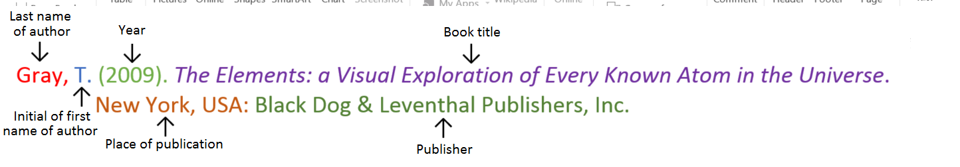
Book
Book with two authors

Shermer, M., & Benjamin, A. (2006). Secrets of Mental Math: The Mathemagician’s Guide to Lightning
Calculation and Amazing Mental Math Tricks. New York, USA: Three Rivers Press.

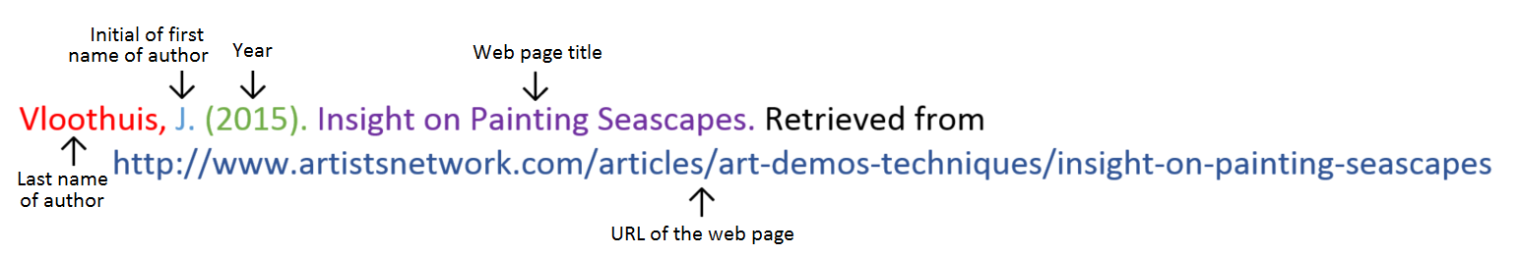
Website
Website with no author (put title of page at the front)

Aranmore Catholic College. (2014). Retrieved from http://www.aranmore.wa.edu.au/

Website with no date

The Zadkine Museum. (n.d). Retrieved from http://www.france.fr/en/museums/zadkine-museum.html

Reference list

Minimum of one reference. (1 mark)

Referenced using the APA referencing style. (1 mark)

_________________________________________________________________________________________________

_________________________________________________________________________________________________

_________________________________________________________________________________________________

_________________________________________________________________________________________________

Presented neatly and clearly. (1 mark)

Correct grammar and spelling. (1 mark)

Uses scientific language. (1 mark)

Contributes equally to group experiment. (1 mark) Total mark: /37 Percentage: %

Teacher’s comments: on Seqta

